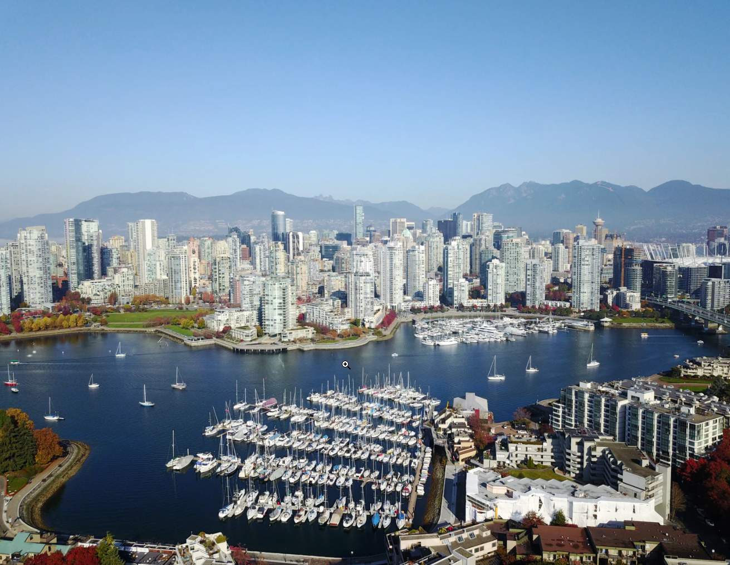

Dogs and Suds: Analysis of locations for a dog bar in Vancouver, BC, Canada.

James R. Cardwell

Aug 07, 2021

Cover photo by Lee Robinson on Unsplash

**Introduction**

* 1. Background

The human relationship with "Man's best friend" goes back more than fifteen thousand years [1]. Archaeological discoveries from Greek and Roman Epitaphs suggest that even two thousand years ago, dogs were more than useful working animals, but a cherished part of the family [2]. In Canada, there are almost 8 million dogs country-wide, and 35% of households have a dog [3,4]. During COVID-19, Canada experienced a surge in pet ownership - 18% of pet owners reported obtaining a new pet since the start of the pandemic, with owners in the 18-24 age bracket most likely (38%) to have purchased a pet since then [4]. COVID-19 has also been responsible for a majority of working Canadians to work from home, with this increased closeness causing the human-dog bond to be even stronger. As COVID-19 restrictions ease, there will be a need for 'outside' activities that do not jeopardize these bonds.

Vancouver, located in British Columbia, Canada, is home to a growing number of craft breweries with more than 20 new breweries being added in the province each year since 2013, with 27 breweries in Vancouver alone as of 2020 [5]. This plethora of breweries supports an even larger number of pubs.

Off-leash beer gardens - dog bars - are a relatively new phenomenon, with a few in the United States, for example:

Paws For a Beer , Bellingham, WA. <https://www.pawsforabeer.com/?fbclid=IwAR1vR_nEbPuP_X_vJ_406pj7Hv4Frbwvf4XkB0jvN57R0N0PVcxLhbtSIMo>

Dog Bar St Pete, St. Petersburg, FL) <https://dogbarstpete.com/?fbclid=IwAR38NEeC8Zo49SXMmkkuhTP2CGJ0O72jJ_tAnsDC-MDUJAPf6Bekntcw9oU>

Taps and Tails Dog Bar, Cleveland, OH  
<https://www.tapsandtailsdogbar.com>

Although there are a few dog-friendly pubs, there are no bona-fide dog bars in Vancouver. A dog bar is like an off-leash dog park with the addition of a full-service bar so that owner and their dog can enjoy quality time socializing, meeting and getting to know new people (and dogs) and have a truly enjoyable outing together. Opening a new dog bar will require detailed and well thought out plan and involves many variables, not least of which is where in the city it would best be located. In this project we will use demographic data combined with data from Foursquare.com to investigate the best neighborhood in which to create a dog bar in Vancouver.

* 1. Business Problem

The problem this project aims to solve is to analyze which locations in the City of Vancouver would be the best in which to create a dog bar. Using Machine-learning techniques such as K-Means Clustering analysis, the project will consider:

* what is the density of dog-owning households in each neighborhood
* which neighborhoods have existing dog parks?
* which neighborhoods have existing pubs?
  1. Target Audience

The key audience for this project will be entrepreneurs looking to open a novel business in an optimum location in Vancouver; armed with the insights gained in this project about where to locate it, they will be able to plan the next phase of their business plan to open Vancouver's first dog bar. In addition, dog owners would benefit from knowing where their nearest dog parks would be, and, barring the introduction of an actual dog bar, if there is a pub on the way to or from the dog park that is dog friendly. Patrons of existing pubs would be interested in the outcome, particularly those with dogs. Owners and potential owners of pubs as well as city planners would also benefit from insights into the locations of other pubs and the degree to which they are dog-friendly provided by this project.

* 1. Rationale

The premise for this study is that for a dog bar, we want to situate the venue in a neighborhood where there are already existing pubs because the owners of those pubs will likely have already analyzed the demographic, transportation, regulatory, real-estate and other variables and concluded that the area is one where pub-goers are likely to frequent. In addition, an area with a high number of pubs typically will increase the likelihood of clientele visiting the area and discovering the dog bar. Similarly, an area with a high density of dogs will mean dog-owners that like to exercise their pets close to home would be more likely to discover and visit the new dog bar. With the addition of a dog bar, dog-owning pub customers in these neighborhoods would now have a new attractive choice of venue. To determine the best location, this project will use the Foursquare API data, apply clustering analysis (such as K-Means clustering) to find and visualize neighborhoods with high numbers of existing pubs and that also correspond to neighborhoods with few or no dog parks but with high levels of dog ownership.

1. **Data**

The sources of data for this project will be as follows. For the purposes of this project, the 22 official neighborhoods of the City of Vancouver, also known as Local Planning Areas, will be used. We exclude data from neighboring cities that make up Greater Vancouver. The University Endowment Lands are also excluded as they are under federal jurisdiction and are not part of the City of Vancouver. The sources of data are as listed and described below. Examples are provided in the methodology section.

1. **Wikipedia.com**

* Description: list and descriptions of the 22 neighborhoods of the City of Vancouver, BC, Canada.
* Source: https://en.wikipedia.org/wiki/List_of_neighbourhoods_in_Vancouver
* Purpose: to identify the names and descriptions of the neighborhoods in Vancouver and, using the beautiful soup library, scrape the table from HTML into a Pandas Data frame.

**2. City of Vancouver Open Data Portal**

* Description: listing of Vancouver's 22 neighborhoods including their names, bounding polygons and centroids
* Source: <https://opendata.vancouver.ca/explore/dataset/local-area-boundary/table/>
* Purpose: to identify the boundaries and central point of each neighborhood in Vancouver, BC

**3. People, Parks and Dogs Strategy Appendix**

* Description: PDF document containing a table containing Statistics Canada 2016 census data on dog-owning households in Vancouver Neighborhoods.
* Source: <https://vancouver.ca/files/cov/people-parks-dogs-strategy-appendix.pdf>   
  Note: since this is a pdf document and we did not cover this in the course, this required researching and using a different library to perform this type of scraping. For this we used the tabula-py library.
* Purpose: to identify neighbourhoods with higher density of dog-owning households

**4. Foursquare API**

* Description: A web-based service that provides suggestions of places to visit (venues) near a user's location as well as tips and ratings from other users of those venues. Foursquare also provides an API that can be used by developers to query the Foursquare data.
* Source:https://api.foursquare.com/v2/venues/explore?&client_id={}&client_secret={}&v={}&ll={},{}&radius={}&limit={}'.format( CLIENT_ID, CLIENT_SECRET, VERSION, latitude, longitude, RADIUS, LIMIT ) where CLIENT_ID, CLIENT_SECRET, VERSION and LIMIT are static, developer and version-specific parameters, and the parameters latitude, longitude and radius cause the API to return venues within RADIUS meters of the geopoint at coordinates specified by latitude and longitude. The key data for this project will be the returned venues for the center point of each neighborhood with categories:
  + - 1) dog park/off-leash area and
    - 2) pub, beer parlour, brewpub or bar.
* Purpose: to use the Foursquare API to identify, visualize and rank the distribution of pubs and existing dog parks across Vancouver neighborhoods.

1. **Methodology**

This analysis has the follow steps. These will be discussed in detail below.

1. Retrieve and pre-process the data.

* Obtain a listing of the neighborhoods in Vancouver using the BeautifulSoup library to scrape the Wikipedia page listed in the first data source, massaging the data and storing it in a Data Frame.
* Obtain the geo-coordinates of the central points (centroids) and the boundaries of the neighborhoods of Vancouver using Pandas to download and read a csv containing them from the City of Vancouver Open Data Portal. * Obtain a listing of dog parks in Vancouver by scraping it from a Portable Data File (pdf) document published by the Vancouver Parks board.
* Use the FourSquare API to identify pubs within a 1.5 km radius of each neighborhood

1. Perform exploratory data analysis to better understand the data. This involved plotting histograms showing licensed dog counts, the counts of pubs and the counts of neighborhoods in each neighborhood.
2. Use K-Means Clustering analysis, an unsupervised machine learning technique to determine the neighborhoods with similar values of dog density, dog park density and pub density.
3. Visualize and characterize the clusters of data to identify candidate neighborhoods for the location of the dog bar
   1. Data Retrieval
      1. Wikipedia data

We used the BeautifulSoup library to extract the page from Wikipedia and then parse the page using python. The list is an unordered html list of which the page contains more than one. First we used BeautifulSoup's FindAll method to get all of the unordered lists, and then used a loop to determine which html "<ul>" tag contains "Arbutus-Greenway" and is therefore our target.

Here is a sample of the first five rows. We retrieved a total of 22 neighborhoods.

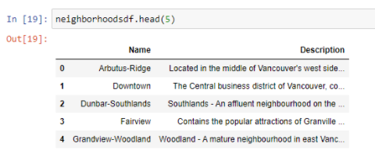

* + 1. City of Vancouver Open Data Portal

The next step was to use Pandas to read and merge the Wikipedia Data Frame with the City of Vancouver Open Data Portal's JSON listing of the centroid and boundary points of each neighborhood, again, wrangling the data so that only relevant columns are retained.

Here is the final listing:

From this site we obtained the geo-coordinates of each neighborhood’s central point.

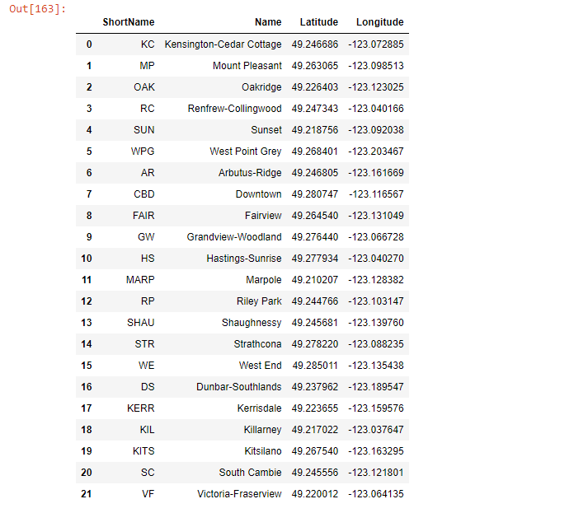

We also obtained boundary point polygons for each neighborhood. Here is a sample of the first five rows:

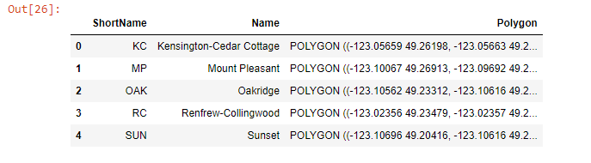

* + 1. Get the population of dogs in each neighborhood

In order to attract dog owners, the new dog bar will ideally be located in a neighborhood in which a maximum number of households have dogs. We will use web scraping to extract data on dog licensing by neighborhood from the People, Parks and Dogs Strategy published by the Vancouver Parks board. We will superimpose this data on a Folium map of Vancouver's neighborhoods to visualize neighborhoods with higher numbers of licensed dogs. We assume that while dog licensing is less than 100%, the degree of compliance is the same across neighborhoods, so the proportion of actual dogs will be somewhat higher by about the same amount in each neighborhood.

The parks board data is in Portable Document format (PDF), which required using another library (Tablula) to scrape the table from the pdf. Here is a sample of the first 5 rows after cleaning the data and merging it with the neighborhood listing:

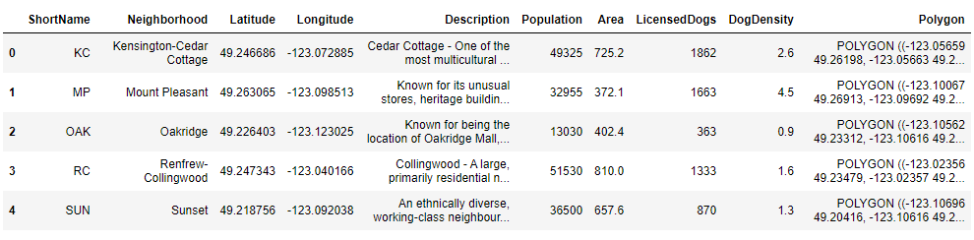

* + 1. FourSquare API Data

The new dog bar should be in a location with few or no existing dog parks, improving the chances that dog owners will patronize the new location. We used the Foursquare API to identify dog parks in close proximity to the neighborhood centroids. Then we visualized these on a map of Vancouver.

To identify existing dog parks, we called the FourSquare API’s search method to locate venues categorized as ‘Dog Run’ or with ‘Dog Park’ in the title. In the search, we used a radius of 1.5km (1500 meters) form the centroid of each neighborhood – this produced some duplicates, which we removed. We identified 27 dog parks and merged the dataset with the neighborhoods and dogs listings.

To identify pubs in each neighborhood, we used the FourSquare API’s search method to search for venues with categories:

* Gastropub
* Irish pub
* Bar
* Pub or
* Brewery

These were combined into a dataset with 330 pub venues.

We validated the 1.5 km radius used in the above search by plotting 1.5km radius circles on a map of Vancouver centered on the geo-location of each neighborhood’s centroid. This confirmed that, although there was some overlap, the unsearched corners of the neighborhoods was minimal:

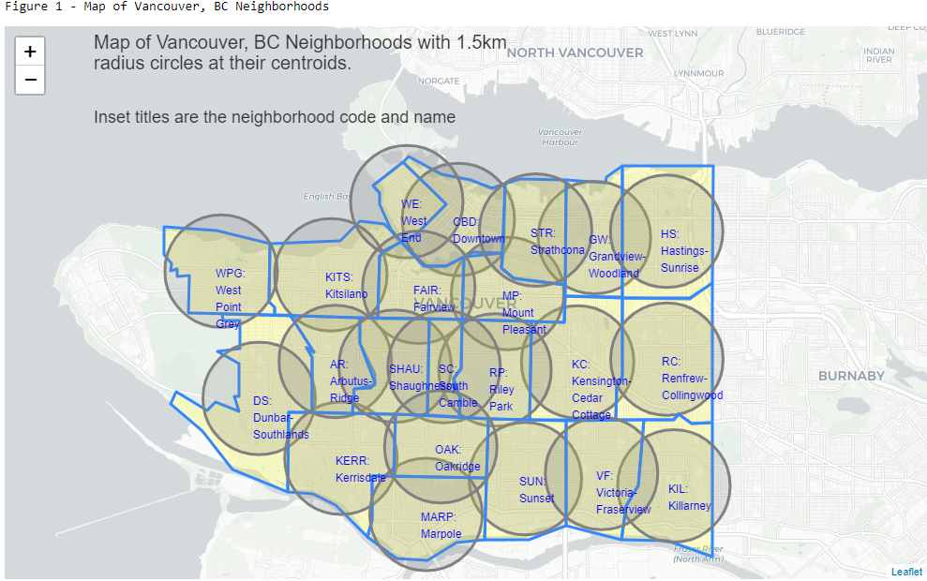

* 1. Exploratory Data Analysis

As a first step before performing clustering, we perform exploratory data analysis to identify any outliers or trends and any other observations about the data

* + 1. Dog counts by neighborhood

Of the 22 neighborhoods, dog density ranges from 0.9 to 6.9 dogs/hectare - a 7 fold difference. The median of 1.7 suggests that the data are skewed and that some neighborhoods have significantly more dogs than others. We created a histogram of licensed dogs by neighborhood.

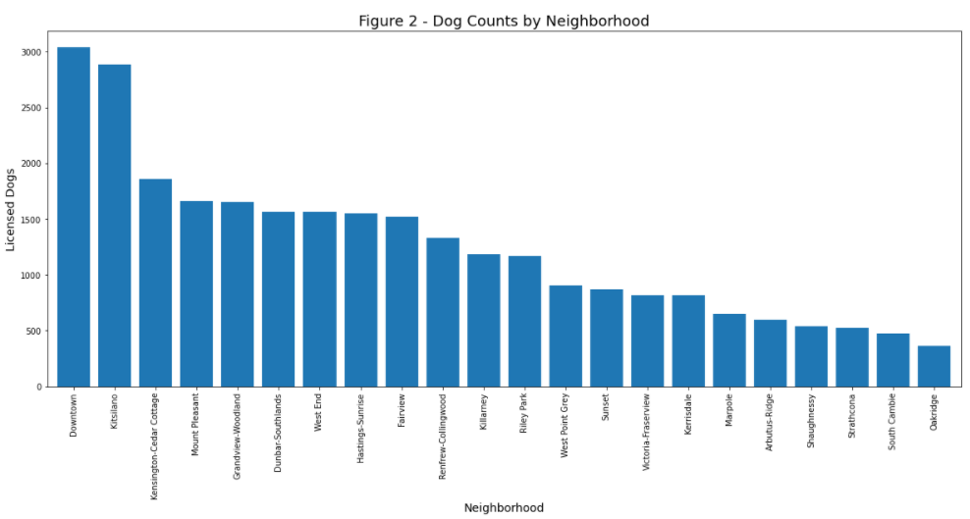

The Downtown and Kitsilano, followed by Kensington-Cedar Cottage have the most dogs, whereas Oakridge, South Cambie, Strathcona and Shaughnessy have the least.

We then visualized the neighborhoods by plotting their boundaries along with dog density using a bubble map:

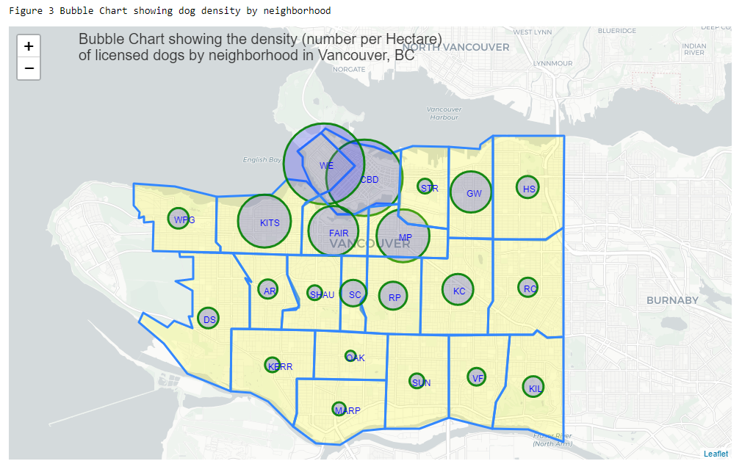

The neighborhoods of West-End and Downtown followed by Kitsilano, Fairview and Mount Pleasant have relatively high density of dogs per hectare ranging from 6.9 to 4.2 dogs per hectare (median 4.5). Conversely, the southern neighborhoods have relatively low dog density with a median of 1.25 dogs / HA.

* + 1. Dog Parks by neighborhood

There are 27 dog parks across the 22 neighborhoods with a median distance (as the crow flies) from the centroid to a dog park of 1,267 meters. Some dog parks are up to 1.75 km away from the neighborhood centroid. Here are the dog park counts by neighborhood:

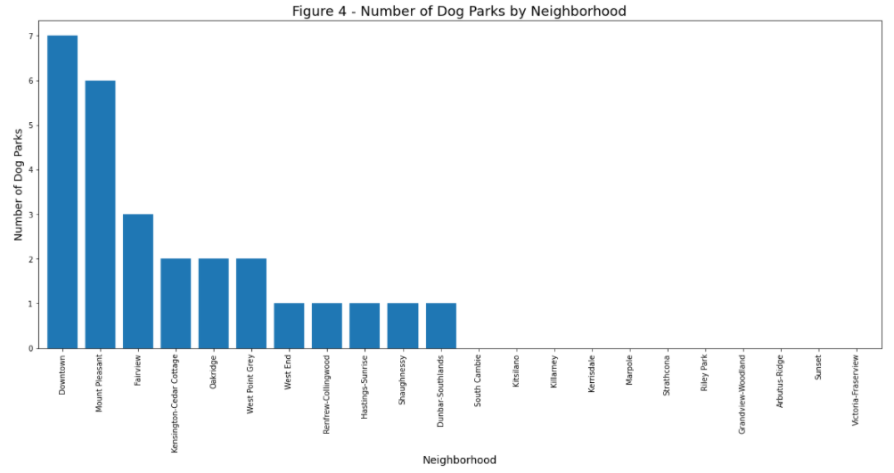

As with the number of dogs, the Downtown neighborhood has the most dog parks followed by Mount Pleasant, Fairview and Kensington-Cedar Cottage. Interestingly, Kitsilano which had the second highest number of dogs had no dog parks within 1.5 km of the central point. Victoria-FraserView, Sunset, Arbutus-Ridge, Riley Park, Strathcona, Kerrisdale and South Cambie also did not have dog parks within 1.5 km of their central points. Next we plotted the locations of the dog parks on a map:

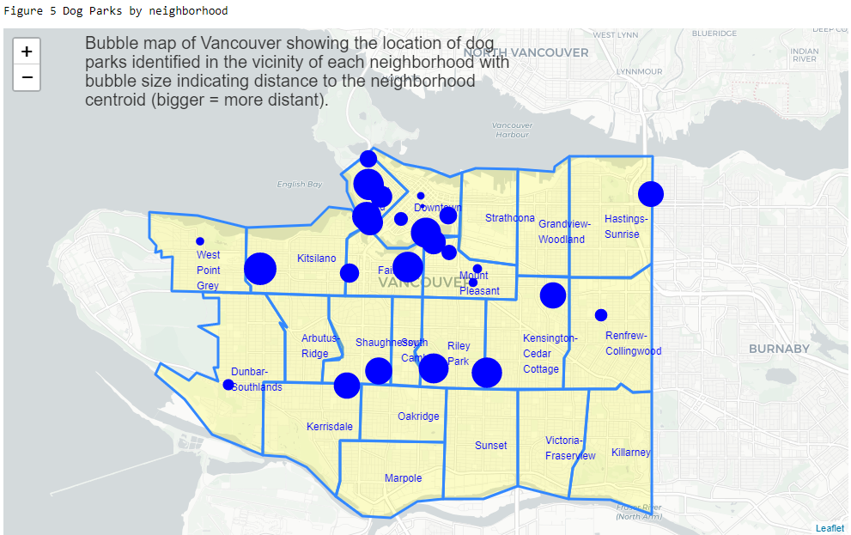

There are clearly several neighborhoods that are less well served by dog parks, some having no dog parks within 1.5 km of the central point.

* + 1. Pubs by neighborhood

The dataset contained 330 pubs. The median number of pubs per neighborhood was 3.5, with a range of 0 to 74 pubs per neighborhood. We also calculated Pub Density (number per hectare) and Park Density (number per hectare) since the K-Means analysis used later on requires that the features be continuous variables, whereas counts are discrete. The following plot shows the number of pubs by neighborhood:

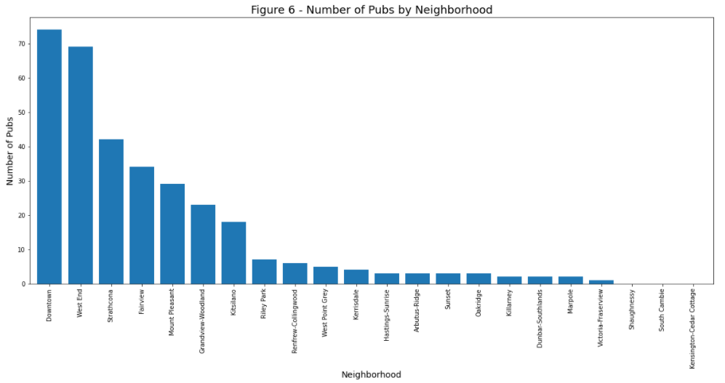

The neighborhoods with the most pubs are Downtown and the West End followed by Strathcona, Fairview, Mount Pleasant, Grandview-Woodland and Kitsilano. The neighborhoods least serviced by pubs are Kensington-Cedar Cottage, South Cambie and Shaughnessy for which we found none. Here is a map of the neighborhoods along with pubs identified:

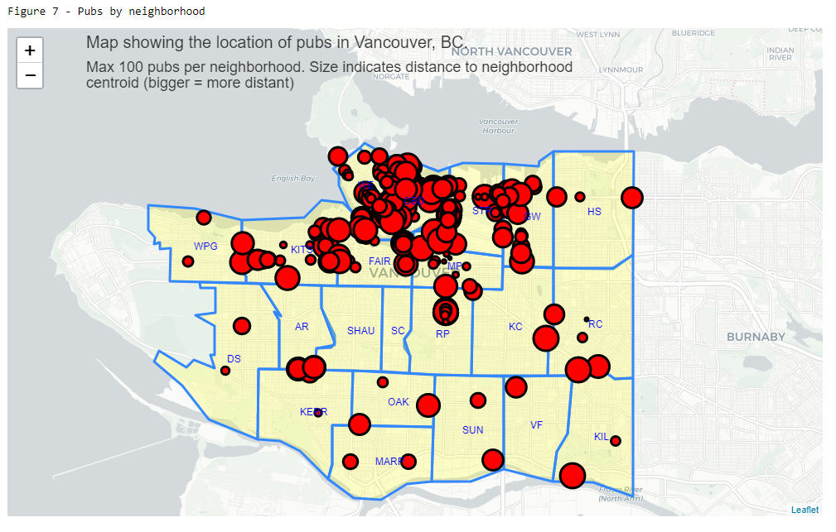

1. **Clustering Analysis**

There are several algorithms for use in cluster analysis - for example, density-based clustering, hierarchical clustering, fuzzy clustering and k-means. For this project, we will use the K-Means clustering algorithm, which is a commonly used technique, is one of the simplest and works well with unlabelled data. With K-Means analysis, we will identify clusters of neighborhoods based on the number of dogs per hectare (dog density), the number of dog parks per hectare (dog park density) and number of pubs per hectare (pub density).

* + 1. Preparation

The K-Means clustering algorithm requires that the data are continuous (not categorical), so we removed columns that are not continuous. Here are the remaining columns to be used in the clustering analysis:

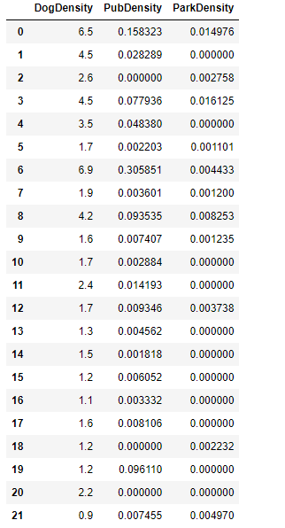

The k-Means algorithm along with many other Machine Learning algorithms requires that all data are continuous variables and that the data have been normalized, and it is obvious from the data that some of the columns have drastically different scale form others. To mitigate against this we used StandardScaler which is a common normalization method and leaves the data with zero mean and standard deviation:

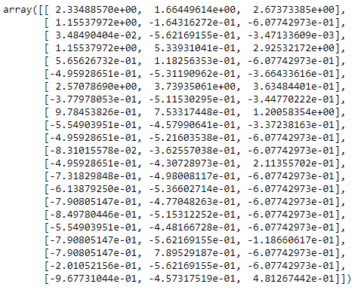

* + 1. Determine the optimum value of K

To determine how many clusters (K), it is common to run the k-means algorithm several times and evaluate the impact of changing 'k' on the within cluster sum of squares (squared Euclidean distance from the value to the mean), also called inertia, each time. We ran the clustering analysis 15 times and used the 'Elbow' method for the evaluation. Figure 8 plots the inertia by number of clusters and identifies the optimal value for K of 4:

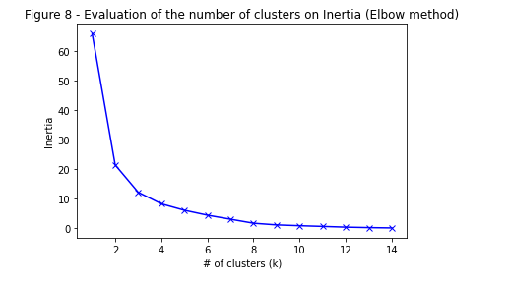

The inflection point (the elbow) at 4 clusters suggests that this is the optimal value for K.

With a value for optimal value for K, we trained the normalized dataset using 4 clusters and plotted the outcome to see how well the neighborhoods are separated using this feature set. Figure 9 shows the 2-D plot:

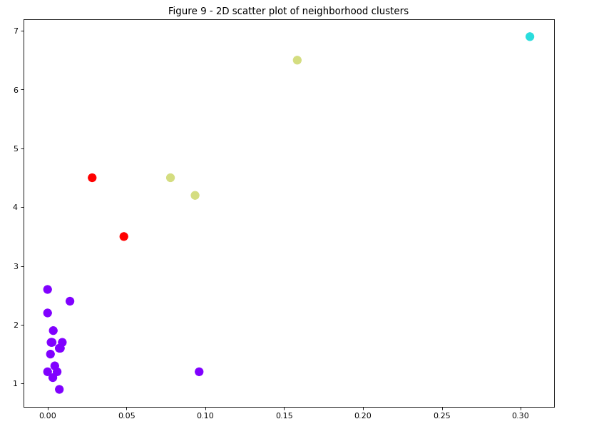

The two-dimensional plot clearly shows that the neighborhoods can be separated by the selected features dog density, pub density and dog park density.

* 1. Visualize and characterise the clusters

We merged the groups from the cluster analysis with the un-normalized data and plotted them on a choropleth map to illustrate where the clusters are located. Figure 10 shows the choropleth map:

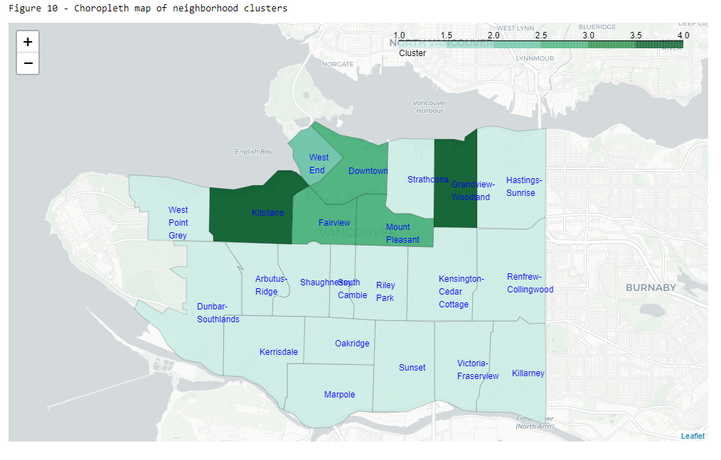

Descriptive statistics for each cluster were used to characterise them:

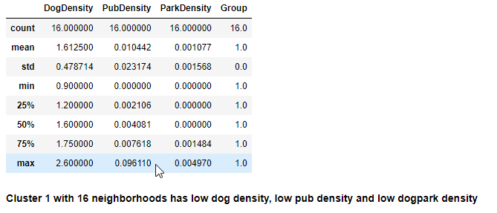

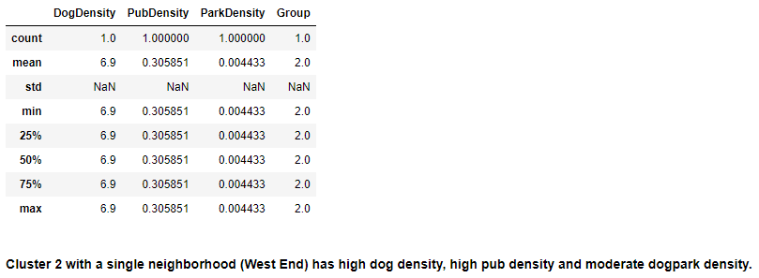

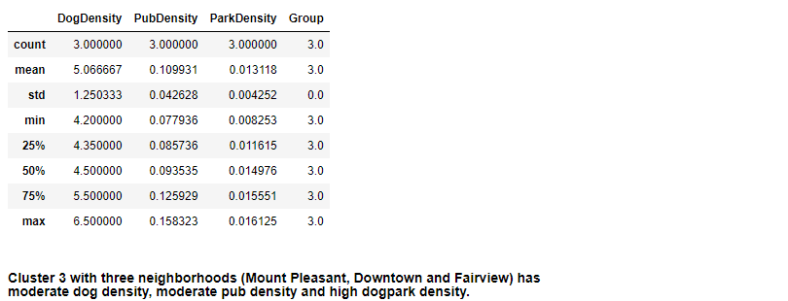

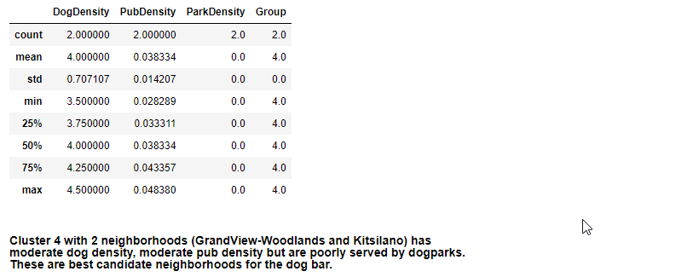

1. **Results**

The K-Means Cluster analysis provided four clusters of neighborhoods in Vancouver. The data suggest that the majority (16/22) of neighborhoods are in the first cluster and can be characterized by low dog density, low pub density and low park density. Neighborhoods in the this cluster would not be good candidates to host a dog bar. These neighborhoods tend to be in the southern two thirds of Vancouver (Fig 10) with older neighborhoods or those with cultures for which pub-going is not a common activity [8].  
  
In contrast, the other three clusters containing 6 neighborhoods are better candidates having moderate to high numbers of licensed dogs per hectare with a range of 3.5 to 6.9 dogs/ha. These clusters also have moderate to high pub densities with cluster 2 (West End) having a higher median pub density than the other two clusters. Higher pub densities combined with higher dog densities means that pub-going dog owners would be more likely to be found in those neighborhoods and therefore more likely to frequent a dog bar.  
  
Finally, cluster 4 (Grandview-Woodlands and Kitsilano) is more poorly served by existing dog parks than either cluster 2 (West End) or 3 (Mount Pleasant, Downtown and Fairview). This suggests that the neighborhoods of Grandview-Woodlands and Kitsilano are the best candidates in which to locate the new dog bar.

1. **Discussion**

**Assumptions**

In this study we made a few assumptions that may or not be realistic.

For example, the dog density data on which this analysis is based are an approximation of the density of dogs in each Vancouver neighborhood. We have assumed that the count of dog licenses in each neighborhood reflects the number of dogs; this may be influenced by the socio-economic status of people in the neighborhoods since licenses cost money and in reality could be skewed towards the richer neighborhoods. Indeed, some of the neighborhoods in the south and east side of Vancouver tend to have lower household income levels than the Downtown and western neighborhoods [7,8] and these neighborhoods also have lower dog densities (Fig. 5).  
  
We have also assumed that the FourSquare data on pubs is accurate. However, pub data accuracy may be influenced by the turnover of venues in neighborhoods with higher growth. The recent COVID-19 epidemic may also have played a role in the closure of some establishments that nevertheless still appear in the FourSquare data. Further analysis may tease out those instances.  
  
We may also have underestimated dog park density in some neighborhoods since the FourSquare results only included venues in which the name contains "Dog Park" or the FourSquare venue had category "Dog Run". However, we see no *a priori* reason that this underestimate would not be uniformly distributed across the neighborhoods.

**Opportunities for further study**

Further analysis could focus on other variables such as socio-economic status of the neighborhoods, a more detailed classification of existing pubs (for example, are some existing pubs 'dog friendly'?) or a broader analysis of dog parks to include other types of parks that dog owners frequent with their pet. Given the recommendations provided here, more detailed breakdown of these two neighborhoods by city block could be used to identify the actual addresses most likely to be successful.  
  
Finally, location is only one in a large number of factors that will influence establishment of a dog bar. Subsequent studies may focus on economic feasibility given the cost of property across neighborhoods, licensing and other factors.

1. **Conclusion**

Dog owners love their pets and need to take them out for exercise. Dog bars allow them to do so while consuming their favorite beverage in a dog-friendly environment, and in doing so enjoy social interaction with like-minded pub-going dog owners. In this study we have gathered and analyzed data from several sources to identify two neighborhood candidates in which to locate Vancouver's first dog bar. Despite caveats regarding the assumptions made, we conclude that the neighborhoods of Grandview-Woodlands and Kitsilano provide the best mix of a dog-owning population, existing pubs to attract visitors and that are poorly served by existing dog parks.

1. **References**
2. Serpell, J. (1995). The Domestic Dog: Its Evolution, Behaviour and Interactions with People. Retrieved from: <https://books.google.com.au/books?id=I8HU_3ycrrEC&lpg=PA7&dq=Origins%20of%20the%20dog%3A%20domestication%20and%20early%20history%20%2F%E2%80%8B%20Juliet%20Clutton-Brock&pg=PA7#v=onepage&q&f=false>
3. Podberscek,Anthony L., Paul, Elizabeth S. and Serpell, James A.(2005) Companion Animals and Us: Exploring the Relationship Between People and Pets. Cambridge University Press
4. Bush (2011). Canada's Pet Wellness Report. Retrieved from: <https://www.canadianveterinarians.net/documents/canada-s-pet-wellness-report2011#:~:text=The%20subject%20of%20pet%20wellness,(source%3A%20Ipsos%20Reid>
5. Chapman, M and Pisani, S. (2020) <https://narrativeResearch.ca/canada-has-seen-a-significant-increase-in-pet-owners-since-the-start-of-the-covid-19-pandemic/>
6. Siren, C (2021) https://www.cahi-icsa.ca/news/2020-canadian-pet-population-figures-released
7. Wiebe, J, 2020. Looking Back on the Biggest Decade in BC Craft Beer History <https://bcaletrail.ca/looking-back-on-the-biggest-decade-in-bc-craft-beer-history/>
8. Wikipedia (2021) List of Neighborhoods in Vancouver. <https://en.wikipedia.org/wiki/List_of_neighbourhoods_in_Vancouver#Official_neighbourhoods> retrieved July 2021
9. City of Vancouver (2016) <https://opendata.vancouver.ca/explore/dataset/census-local-area-profiles-2016/information/>
10. Vancouver Park Board (2017) People Parks & Dogs: A strategy for sharing Vancouver's parks: <https://vancouver.ca/files/cov/people-parks-dogs-strategy-report.pdf> and the appendix: <https://vancouver.ca/files/cov/people-parks-dogs-strategy-appendix.pdf>